Supply Chain Data Analysis

**Problem Statement**

The FMCG manufacturer, GDS Mart headquartered in Gujarat, India is currently operational in three cities Surat, Ahmedabad and Vadodara. They want to expand to other metro/tier1 cities in the next 2 years.

GDS Mart is currently facing a problem where a few key customers have not extended the annual contract due to service issues. It is speculated that some of the essential products were either not delivered on time or not delivered in full over a continued period, which could have resulted in bad customer service. Management wants to fix this issue before expanding to other cities and requested their supply chain analytics team to track the ’On time’ and ‘In Full’ delivery service level for all the customers on the daily basis so that they can respond swiftly to these issues.

**Requirements**

* Create the metrics according to the metrics list( Below)
* Create a dashboard according to the requirements provided by stakeholders in the business review meeting
* Create relevant insights that are not provided in the metric list/stakeholder meeting.

**Metrics List**

|  |  |  |  |  |  |
| --- | --- | --- | --- | --- | --- |
| **Sno** | **Measures** | **Abbreviation** | **Description** | **Table** |  |
| 1 | Total Order Lines |  | Count of all order lines in fact_orders table | fact_order_lines |  |
| 2 | Line Fill Rate | LIFR % | Number of order lines shipped In Full Quantity / Total Order Lines | fact_order_lines |  |
| 3 | Volume Fill Rate | VOFR % | Total Quantity shipped / Total Quantity Ordered | fact_order_lines |  |
| 4 | Total Orders |  |  | fact_orders_aggregate |  |
| 5 | On Time Delivery % | OT % | Number of orders delivered On Time / Total Number of Orders | fact_orders_aggregate |  |
| 6 | In Full Delivery % | IF % | Number of orders delivered in Full quantity / Total Number of Orders | fact_orders_aggregate |  |
| 7 | On Time In Full % | OTIF % | Number of orders delivered both IN Full & On Time / Total Number of Orders | fact_orders_aggregate |  |
| 8 | On Time Target |  | Average of On-Time Target | dim_targets_orders |  |
| 9 | In Full Target |  | Average of In-Full Target | dim_targets_orders |  |
| 10 | On Time In Full Target |  | Average of OTIF Target | dim_targets_orders |  |
|  |  |  |  |  |  |

**Data Files**

1. dim_customers.csv

2. dim_products.csv

3. dim_date

4. dim_targets_orders

5. fact_order_lines.csv

6. fact_orders_aggregate.csv

**Data Flows**

The above figure shows the data flows among the different tables.

**Tools/components used**

* Microsoft Power BI for data cleaning and data visualization
* Microsoft Word for documentation

**Dashboard**

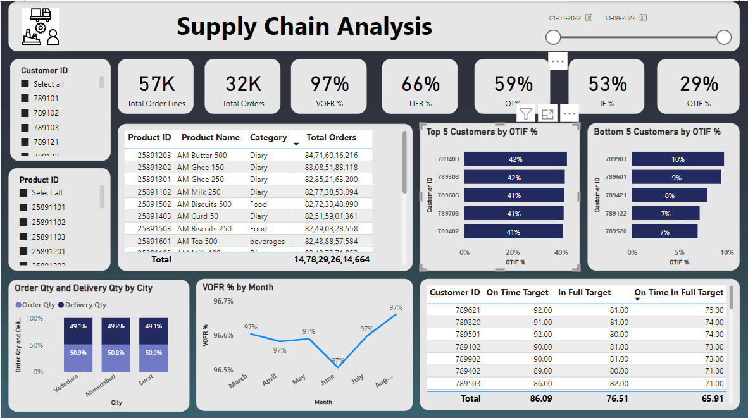

The above figure shows the dashboard developed for the supply chain analysis.

**Analysis**

* The customers with customer IDs 789403 and 789903 have the highest and lowest On Time In Full %
* The product AM Butter 500 has the highest number of orders
* Volume Fill Rate % is lowest in the June month and it is increased to higher level in August month
* All the targets - On Time Target, In Full Target, and On Time In Full Target are highest for the customer with customer ID 789621
* Currently the ratio of order quantity and delivery quantity is almost same in the cities Surat, Ahmedabad and Vadodara

**Conclusion**

The supply chain analysis for the FMCG manufacturer – GDS is done for the time period – March 2022 to August 2022